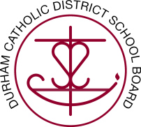
Durham Catholic Parent Involvement Committee
Thursday, September 14, 2017
DCDSB – Board Room
7:00 – 9:00 PM

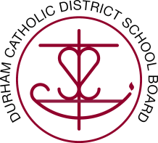

AGENDA
- CALL TO ORDER

A.1 Opening Prayer
A.2 Welcome and Courtesies

- APPROVAL OF AGENDA

- ANNOUNCEMENTS

C.1 Next Durham Catholic Parent Involvement Committee Meeting: October 5, 2017

- ACTIONS TO BE TAKEN

D.1 Approval and Signing of the Minutes of the Open Session of the Durham Catholic Parent Involvement Committee Meeting of May 11, 2017.
D.2 Selection and approval of school representation per DCPIC members

- PRESENTATIONS

- REPORTS/ INFORMATION/ DISCUSSION ITEMS

F.1 Standing Items

F.1.1 Chair’s Report
F.1.2 Trustee’s Report
F.1.3 Resource Report
F.1.4 PRO Grant Subcommittee Report
F.1.5 Communications Subcommittee Report
F.1.6 School Council Outreach Subcommittee Report
F.1.7 Faith Formation Subcommittee Report
F.1.8 Policy & By-Law Subcommittee Report
F.1.9 Budget Subcommittee Report

- ADJOURNMENT

- CLOSING PRAYER

